Simulation of Engineering System 3 (ENG3036)
Assignment Report Template Part 1
Student Name: Gregor Johnston
Student Number: 2773209J
- Assignment Topic: Position Control System for a Robotic Arm
1.0 Introduction for Part 1
The chosen assignment was the robotic arm system, a system that simulates the movement of the elbow joint of a robotic arm when changes are made to its reference angle. When the reference angle (θ_{Fref}) is set or changed, the amount of voltage (and therefore current (i)) required to move the arm is changed accordingly to turn the deflection angle of the actuator (θ_{M}) which changes the deflection angle of the first gear “gear 1” (θ_{G1}). Through a gear ratio (GR), the deflection angle of a larger gear “gear 2” (θ_{G2}) is rotated. This second gear is equivalent to the deflection angle of the forearm (θ_{F}).
The system is a closed feedback loop, therefore it will continue rotating the deflection angle of the forearm until the actuator deflection angle (θ_{M}) has reached the desired reference deflection angle (θ_{Fref}), after which it will stop and await a new θ_{Fref} change. This report details the process of deriving the state space equations, implementing the state space equations into MATLAB scripts, choosing an appropriate integrator and step size and creating a Simulink model to compare results.
Mathematical Modelling & Continuous Time Simulation
  - State Space Model Derivation
To derive my state space model, I first had to gain an understanding of the entire system, noting down all important equations. After that I made note of all the dynamic parameters in all the equations which helped me select my chosen states. I then derived my 7 states by rearranging and reducing for the highest order derivative or the dominating variable which resulted in my state space equations listed below.
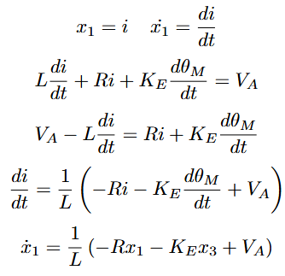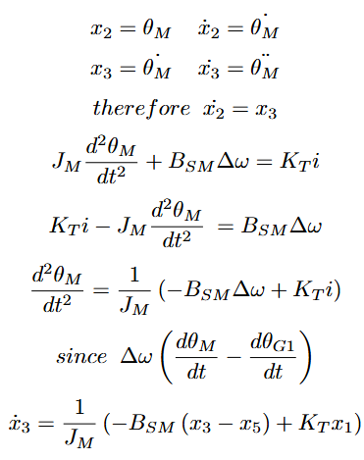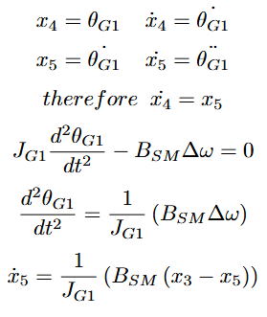
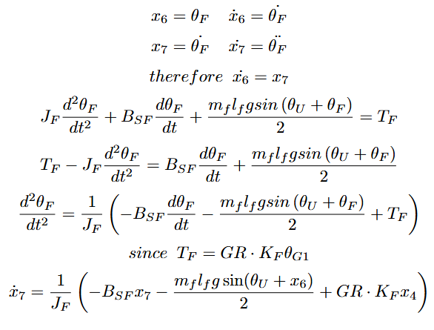
Figure 1: States and State Space Model Equations
  - Matlab Model Function
The below model is a function in a separate file (roboarmmodel.m) from the main script, which is called in derivative section of my dynamic segment. It passes in the matrix of states (x) and the “compensated voltage” (V_{A}) as well as calling all the global constants to be used in the equations. This allows for all the state derivatives to be calculated and returned as a matrix (xdot).
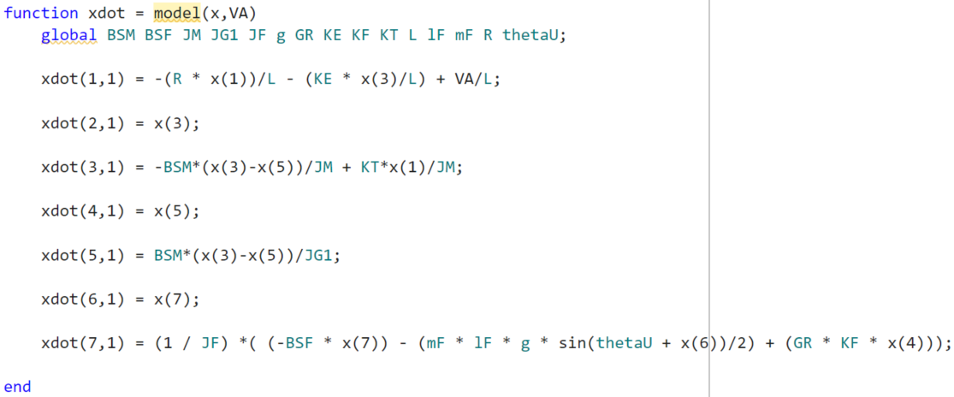
Figure 2: MATLAB model

  - Initial Conditions, Numerical Integration Solver & Step-Size Selection

The initial conditions for the system are given in the specification document, which I have saved in a separate file (const.m). The most noteworthy value in this file is the reference angle (θ_{Fref}), which is set to an initial condition of 55° (≈ 0.959 radians).

The chosen numerical integration solver was the Runge-Kutta 4th Order Method. This is because it takes more computing power but produces a much more accurate result due to its ability to evaluate the system's dynamics at multiple points within each step, reducing numerical errors and improving stability.

A step size of 0.001 was chosen to capture small changes in the rapidly changing dynamics of the system. The smaller you set this number, the more computational power is needed since the computer will be performing calculations with numbers that are closer and closer together. Therefore, after experimenting with different step size values, 0.001 is a good balance between good accuracy of points and not using too much unnecessary computational power.

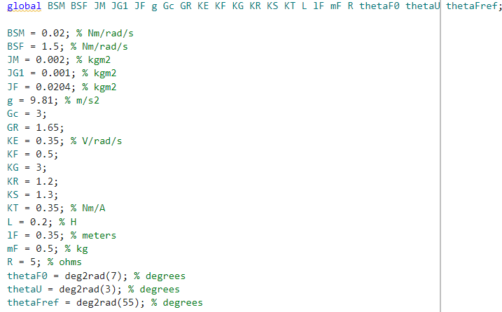
Figure 3: Constants and Initial Conditions

  - Simulation Responses and Analysis
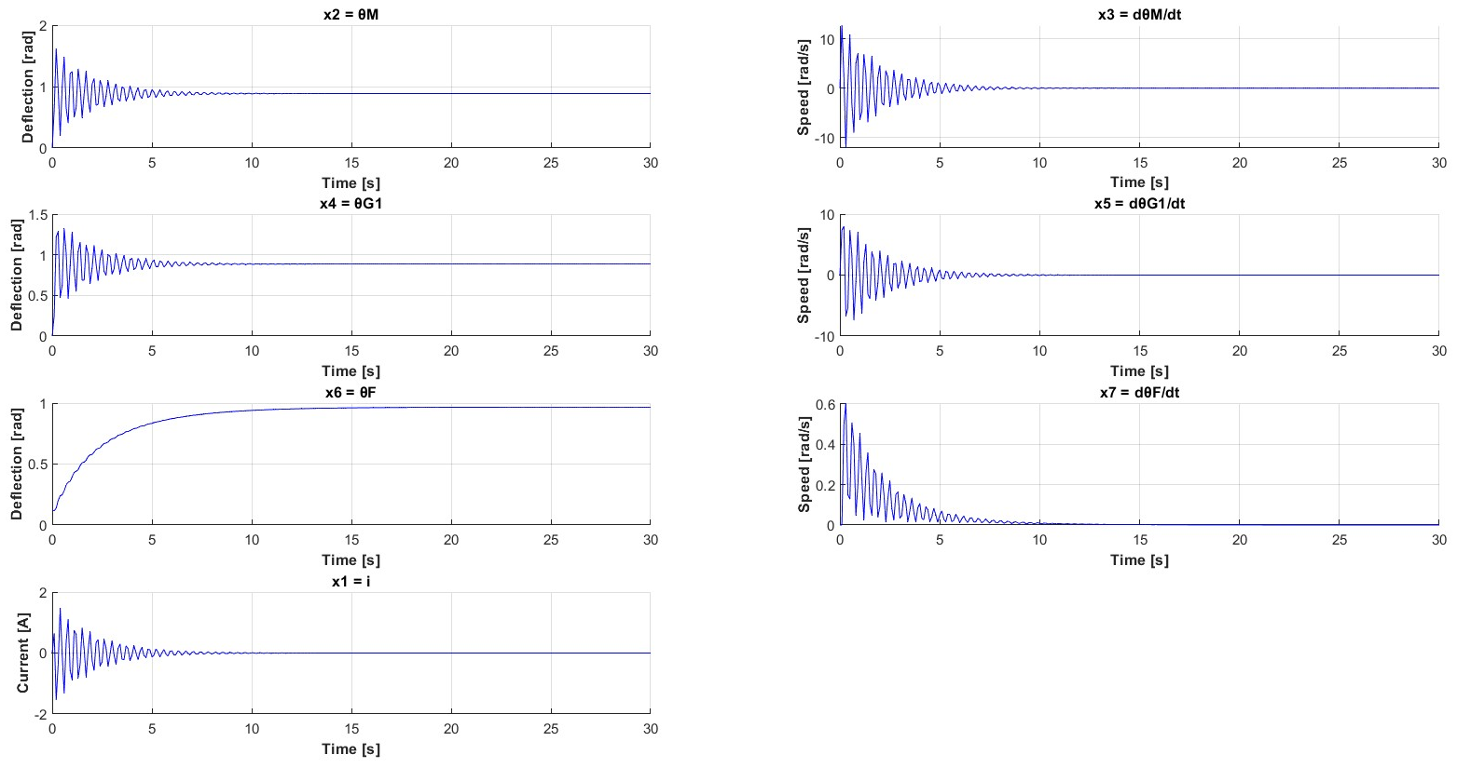
Figure 4: MATLAB Simulation Output
Each state was plotted separately, and the results show that every state settles at their steady state at around 10 seconds, which is slow for a robotic arm system that may require quick and precise movements. As can be seen for all (excluding x6), the responses are underdamped with long settling times and significant overshoot. The reason x6 is excluded from this underdamping is because it has a much higher B_{SF} value (1.5Nm/rad/s), which has a big impact on the dampening of the output signal. x6 also has a much higher inertia value J_{F} (0.0204kgm²) which gives x6 a much more concise and gradual response when given rapid changes. States x2 and x4 reach a steady state of ≈ 0.88 radians (≈ 50°) which differs from the reference angle (θ_{Fref}) of 55°. These deflections will not reach 55° due to gravity on the system and the gains given in the initial conditions. It also undergoes steady state error due to the proportional controller Δθ which, without an integral component, will always have a small offset error.
Block Diagram & Validation
  - Simulink Block Diagram

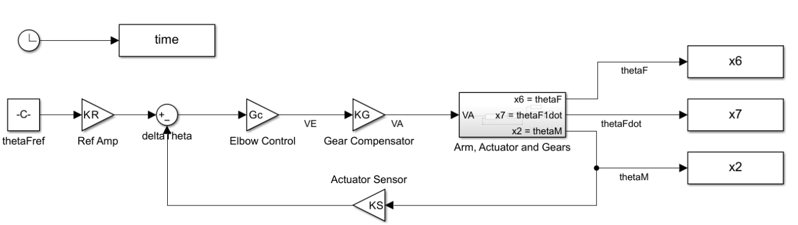
Figure 5: Elbow Control System

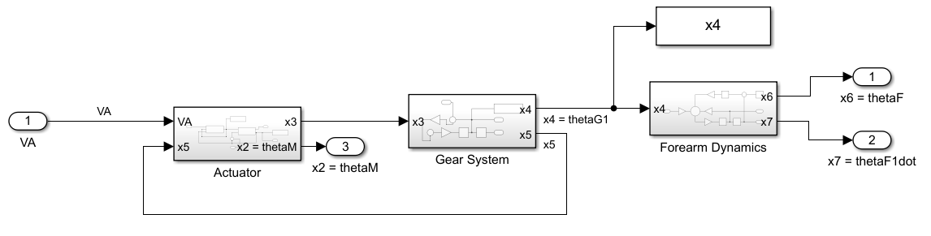
Figure 6: Arm, Actuator and Gears

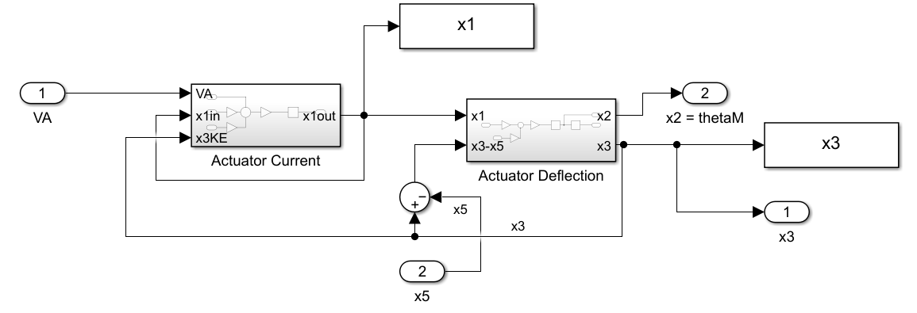
Figure 7: Actuator

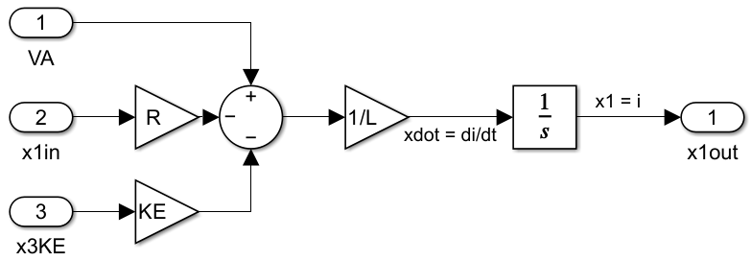
Figure 8: Actuator Current

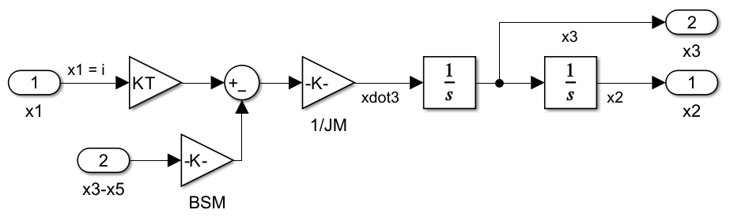
Figure 9: Actuator Deflection

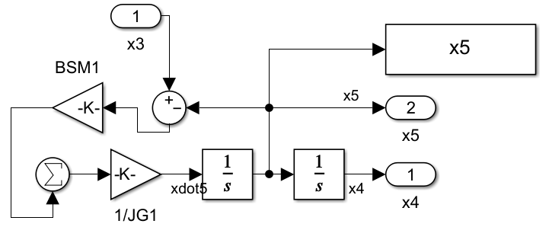
Figure 10: Gear System

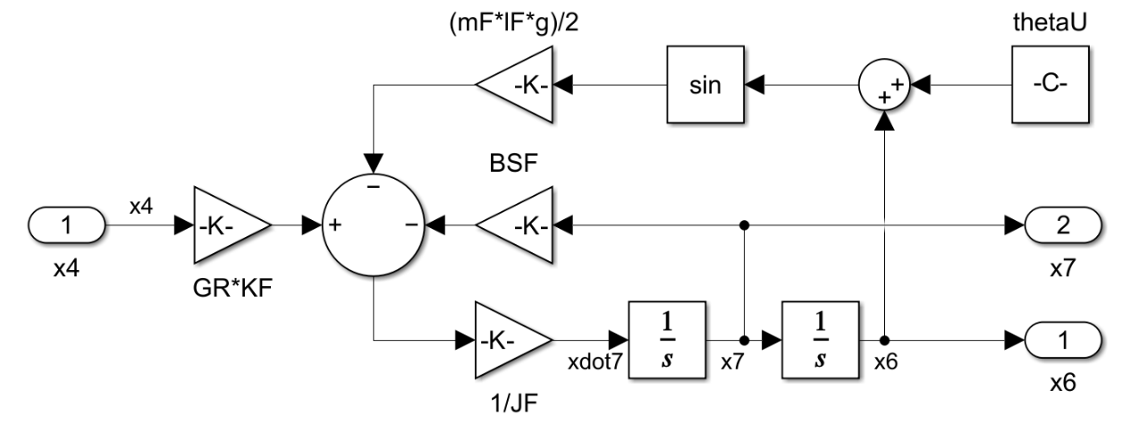
Figure 11: Forearm Dynamics

The above diagrams are the block diagrams created in Simulink. I based these diagrams on the diagrams given in the specification document. They give a graphical representation of the robot arm elbow control system. Figure 5 is the general system overview, clearly showing the closed feedback loop system where it is comparing the reference angle (θ_{Fref}) with the actuator defection (θ_{M}) which drives the system (based on figure 5 of the specification).

Figure 6 shows how the actuator, gears and forearm are all interconnected (based on figure 6 of the specification). Figure 7 shows the relationship between the actuator current (i) and the actuator deflection angle (θ_{M}). It also shows how the difference between actuator speed (dθ_{M}/dt) and gear 1 speed (dθ_{G1}/dt) is calculated using the summing block. Figures 8 and 9 show how the actuator current (i), actuator deflection (θ_{M}) and actuator speed (dθ_{M}/dt) are derived. Figure 10 shows how the gear 1 deflection (θ_{G1}) and gear 1 speed (dθ_{G1}/dt) are derived, again using the difference in speeds as seen in figure 7. Figure 11 shows how the forearm deflection (θ_{F}) and forearm speed (dθ_{F}/dt) are derived, which makes use of the gear 1 deflection (θ_{G1}). Figures 8 to 11 correspond to their state space equations in derived in figure 1 of this report.
  - Validation Using Simulink Responses and Analysis

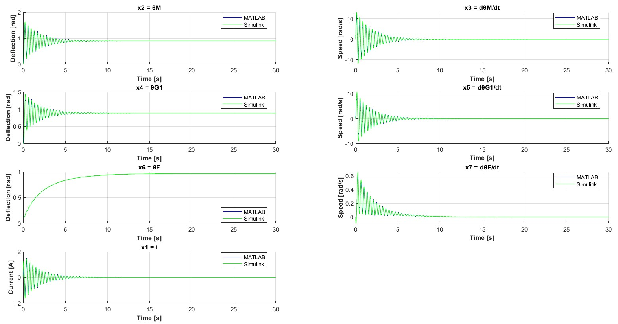
Figure 12: Block Diagram Output (Green) versus MATLAB Output (Blue)

The Simulink simulation response was plotted against the MATLAB simulation response so the differences could be identified. When zooming in to compare the models, the Simulink response validates the MATLAB scripts response, since both the output transients on all the plots are equivalent. When comparing each states plotted output, they all match in frequency and settle at the same steady state conditions. Simulink gives a much smoother output when zooming in. It appears to be a more continuous signal whereas MATLAB is much more discrete looking with jagged peaks, appearing to have less samples taken. This is because the MATLAB response uses a script-based integrator whereas Simulink uses a built-in integrator, which cause them to have their own discrepancies.
1.7 Conclusions for Part 1
This report shows that the robotic arm system has room for improvement. It can be seen in the simulation outputs that there is a large amount of underdamping, which leads to high amounts of oscillation in the responses, which is not ideal for a system that needs high precision. There is also the steady state error with actuator deflection θ_{M} and gear 1 deflection θ_{G1} which is another aspect that needs to be improved.
These issues could be solved by different gain and inertia values in the initial conditions and constants file, as well as adding an integral component in the proportional controller. These solutions would cause a greater damping effect that would give more readable and concise signals and reduce the amount of offset error in the deflection angles, leading to a more accurate and reliable simulation response.
Writing this report has helped in my understanding of simulating dynamic and complex engineering systems, helping to improve my skills with Simulink and my understanding of deriving state space equations.

